IT- 603 Lab 1
Kunal Adwani | 202612050
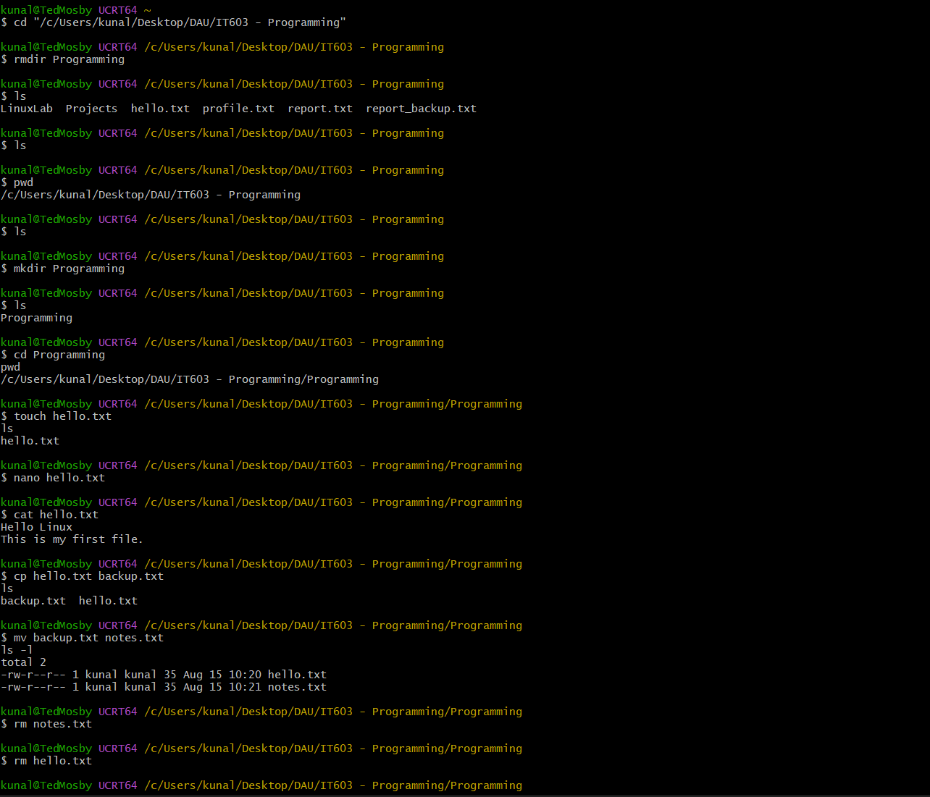
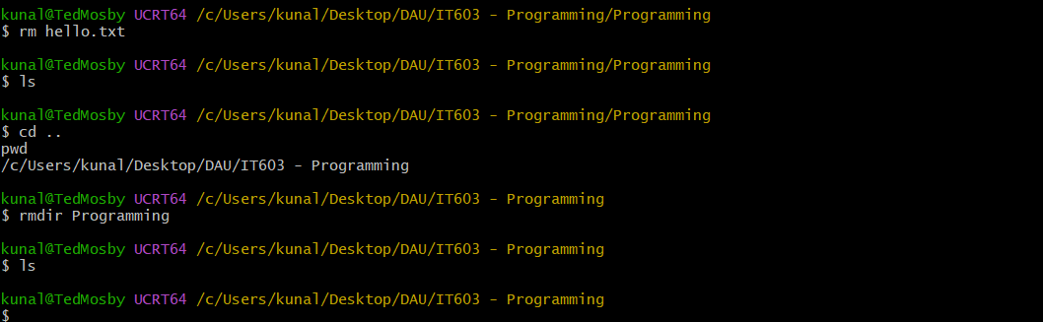
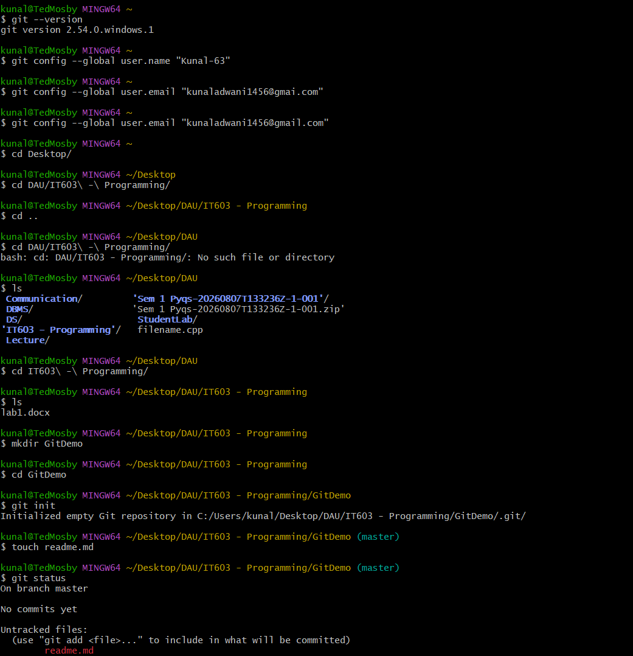
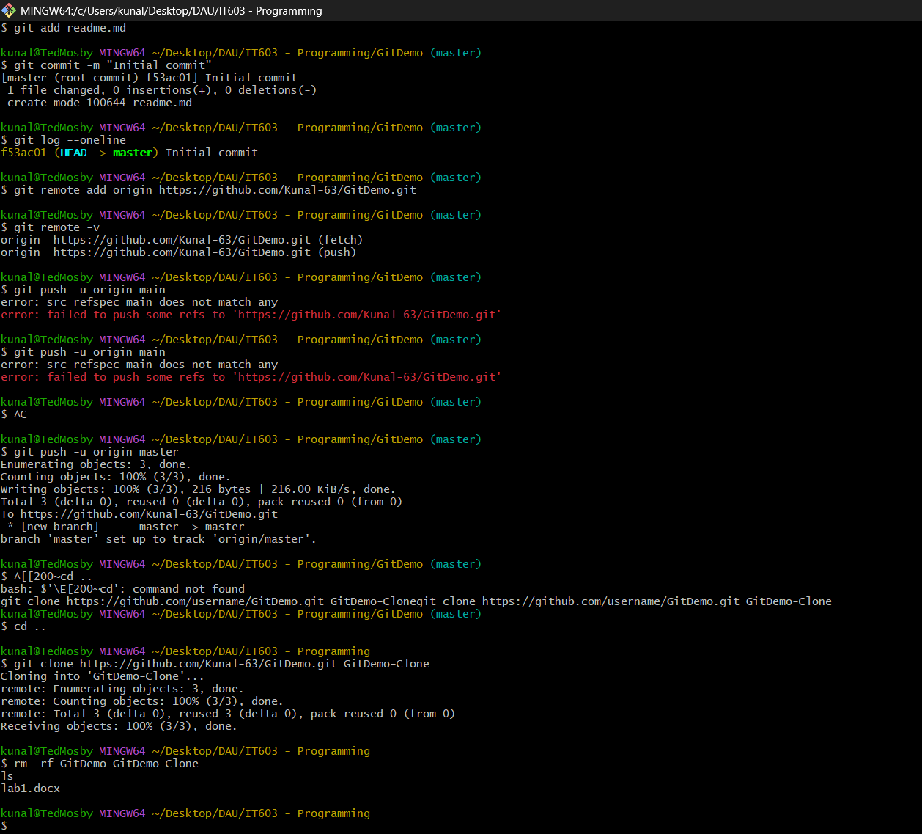

Exercises
- Create Your Personal Workspace
  - Create a directory named StudentLab. Inside it, create the following subdirectories:
    - • Programs
    - • Assignments
    - • Notes
  - Verify the directory structure and display the current working directory.
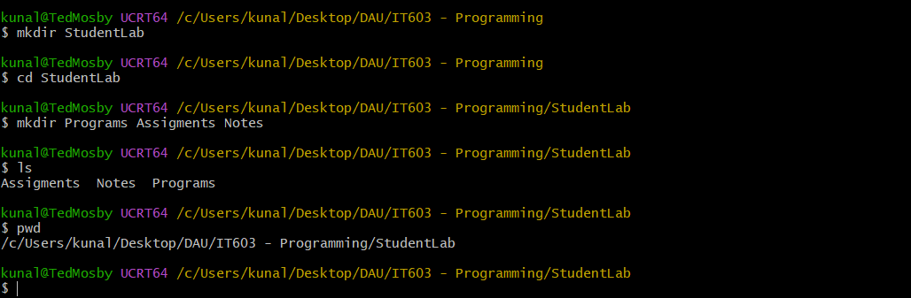
- File Management Practice
  - Inside the Assignments directory:
    - Create the files:
      - assignment1.txt
      - assignment2.txt
      - assignment3.txt
  - Do all using Command Lines learned in this Lab.
  - Rename assignment3.txt to lab3.txt.
  - Delete assignment2.txt.
  - Display the remaining files.

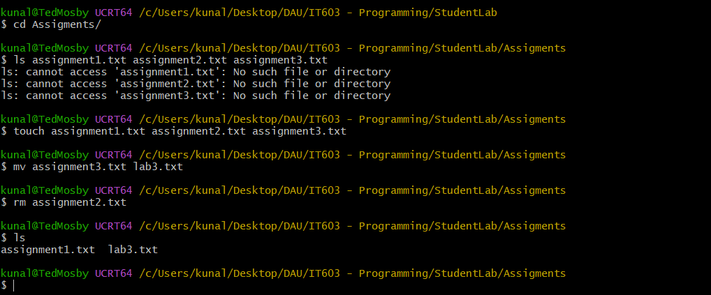
- Creating and Editing Files
  - Create a file named profile.txt using the Nano editor.
  - Enter the following information:
    - Name
    - Enrollment Number
    - Department
    - Favourite Programming Language
  - Save the file and display its contents using the terminal.
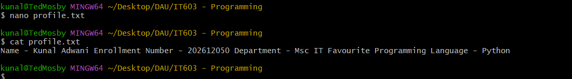
- File Copy and Backup
  - Create a file named report.txt.
  - Copy it to a new file named report backup.txt.
  - Edit only the backup file and add one additional line.
  - Finally, display both files and verify that the original file remains unchanged.
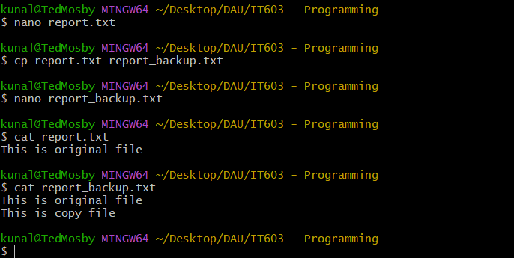
- Directory Tree Creation
  - Create the following directory structure:
  - LinuxLab
    - C
    - C++
    - Python
    - Java
  - Inside each directory, create a file named program1.txt.
  - Display the contents of every directory.
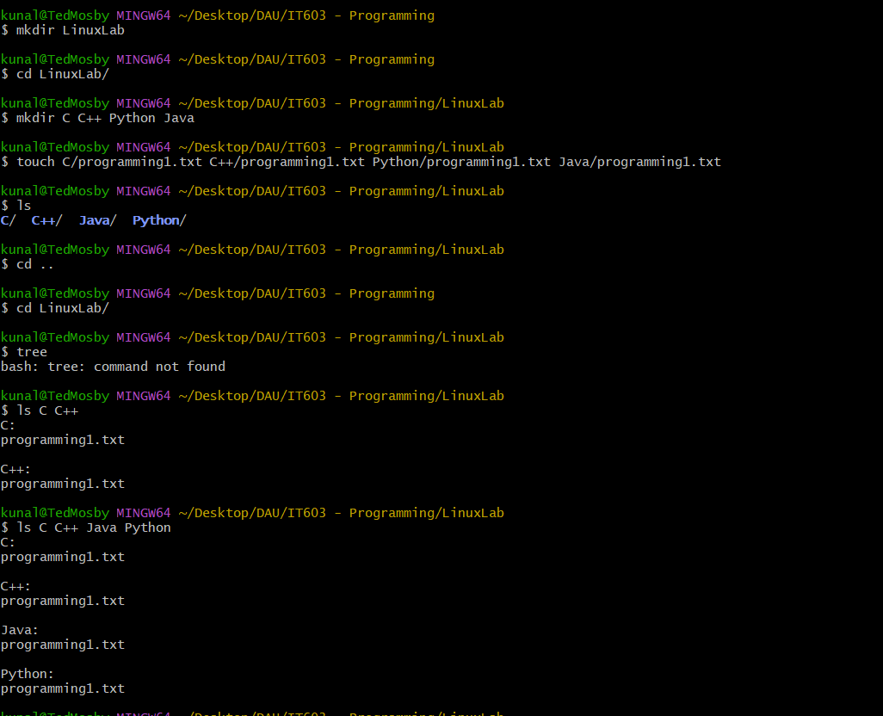
- Directory Management
  - Create the following directory structure:
    - Projects
      - AI
      - ML
      - DL
  - Perform the following operations:
    - Delete the ML directory.
    - Rename the DL directory to DeepLearning.
    - Verify the final directory structure.
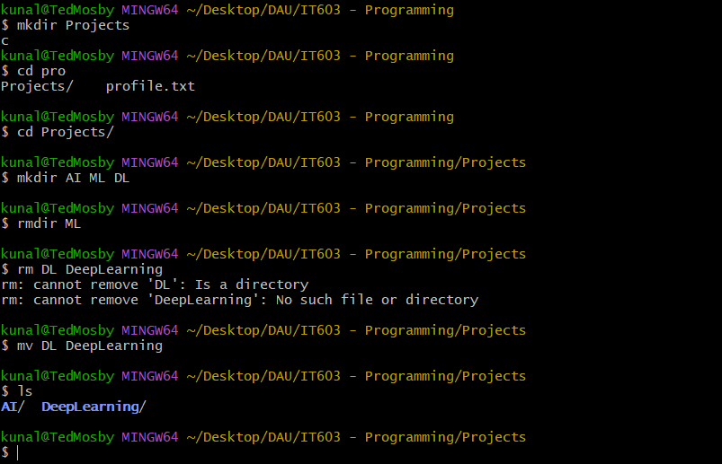
- Compile and Execute a C++ Program
  - Write a C++ program that accepts one string and displays is it a palindrome or not.
  - Compile the program using the GNU C++ compiler and execute it from the terminal.
  - Record both the compilation command and the program output.
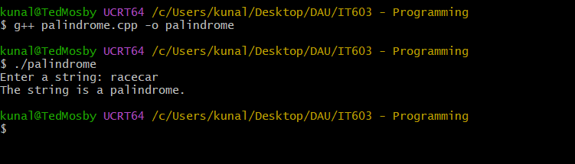
- Git Repository Basics
  - Create a directory named GitPractice.
  - Inside it:
    - Initialize a Git repository.
    - Create a file named readme.md.
    - Stage the file.
    - Commit the changes with the message First Commit.
    - Display the repository status.
    - Display the commit history.
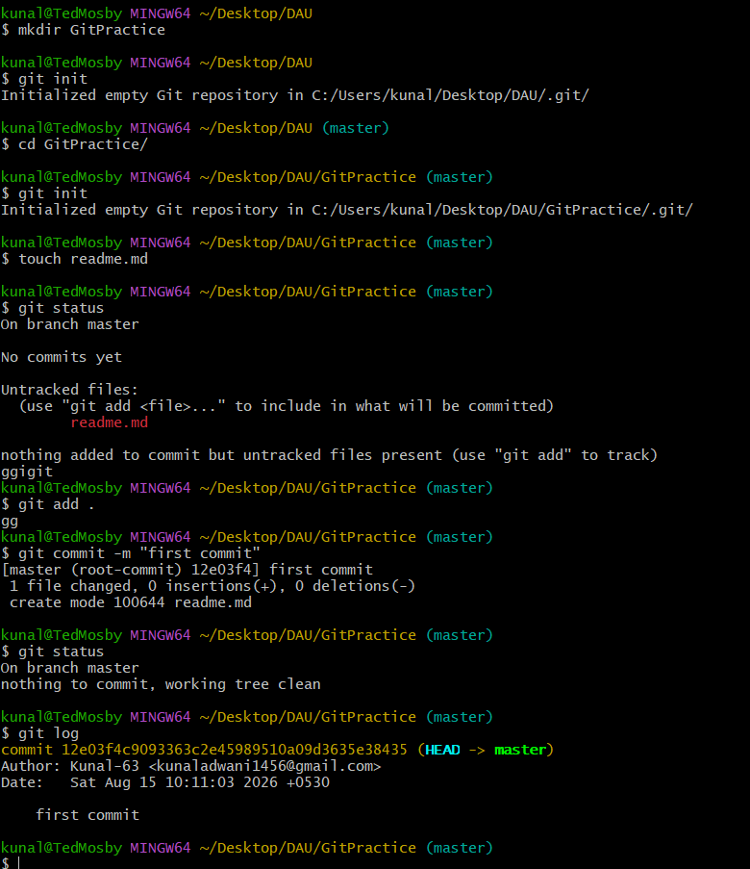
- Mini Linux Project
  - Create the following directory structure:
  - Library
    - Books
    - Notes
    - Assignments
  - Perform the following tasks:
    - Create the files:
      - booklist.txt
      - notes.txt
      - assignment.txt
  - Copy booklist.txt into the Notes directory.
  - Rename the copied file to library books.txt.
  - Delete assignment.txt.
  - Display the final directory structure.
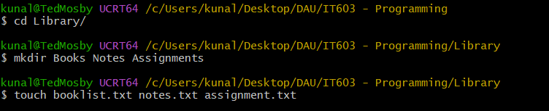
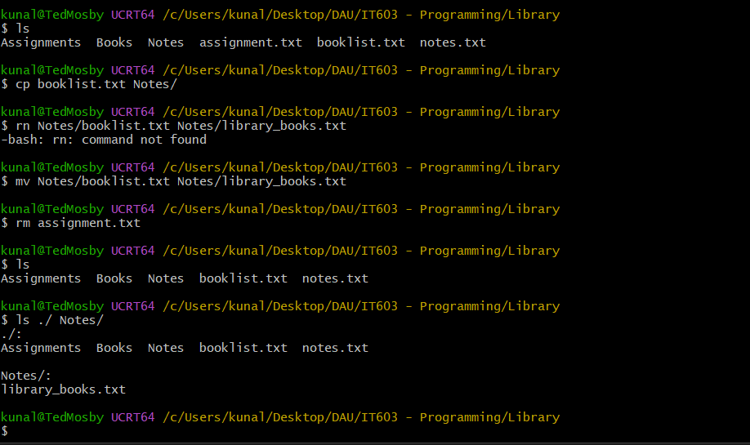
- Linux Command Challenge
  - Create the following final directory structure without using any graphical interface:
    - Student
      - Programs
      - cpp.cpp
      - python.py
    - Documents
      - resume.txt
    - Backup
      - resume_backup.txt
  - Requirements:
    - Create all required directories.
    - Create all required files.
    - Add suitable text to resume.txt.
    - Copy the file into the Backup directory.
    - Rename the copied file to resume backup.txt.
    - Remove any unnecessary files created during the process.
    - Display the final directory structure.
    - Print the current working directory.
